Business Requirements Document

of the Website

For

Bazaar Ceramics



Institute of Technology Australia

*Author:* Alessandro Ferro

|  |  |
| --- | --- |
| **Version History** | |
| **Version #** | **Date** | | **Revised By** | **Reason for change** |
| **1.0** | **12/03/2021** | | **Alessandro Ferro** | **NA** |
|  |  | |  |  |
|  |  | |  |  |
|  |  | |  |  |

Contents

1. Introduction 3

1.1. Purpose 3

1.2. Target Audience 3

1.3. Project Scope 3

1.4. Document Conventions 4

1.5. Reference 4

2. Description 4

2.1. Features 4

2.2. User Overview 5

2.3. Operating Environment 6

2.4. Constraints: Implementation/ Design 6

2.5. Documentation 7

2.6. Assumptions/ Dependencies 7

3. Functional Requirements 9

3.1. Requirement 1 9

3.2. Requirement 2 11

3.3. Requirement 3 13

4. Requirements of External Interface 16

4.1. User Interfaces 16

4.2. Hardware Interfaces 18

4.3. Software Interfaces 18

4.4. Communication Interfaces 18

5. Non-functional Requirements 18

5.1. Performance 18

5.2. Security 19

Quality 19

# Introduction

# Purpose

The purpose of this document is to define the technical aspects related to the development and subsequent implementation of the Bazaar Ceramics Website V1.0.

The Bazaar Ceramics Website is an ecommerce website with online payment capabilities, customers account implementation and administrative functionalities for management of customer accounts and inventory and for calculation and representation of sales figures.

# Target Audience

This document is targeted to any person that is going to work on, or with the system. This includes developers, designers, business owner, testers and management.

The document focus on technical matters is approached trying to use a language that wouldn’t preclude its understanding by people without a technical background.

The first section of the document offers an introduction and define the scope of the project.

The second section discusses in details the characteristics of the product, what it is, what it does and in which environment it will operate.

The third section lists and expand on the technical requirements, listing the technical criteria that will be used to define and evaluate the system

The fourth section details the interfaces used by the system to communicate with its users and with other systems.

The fifth and last section outlines the non functional requirements in regard of performance, security and overall quality of the system.

# Project Scope

The scope of this project is to deliver to Bazaar Ceramics a fully functional ecommerce website and related deliverables, to address the company’s business needs.

The software in exam in this technical specification will

* Showcase the company’s catalogue
* Provide online payment gateway
* Improve customers relationships management
* Streamline administrative tasks and creation of sales figures.

As a result, the company expects to

* Cut down marketing related costs
* Increase their presence on interstate and international markets
* Improve customers retention
* Implement a strategically targeted approach to production

# Document Conventions

* Headers use the default “Heading 1” style of MS Word.
* Section text use “Calibri (Body)” font size 11
* Sub section headings use “Calibri Light” font size 14
* List use round black bullets and have one level of indention
* Sublists use empty round bullets and have one extra level of indention
* Table headings are bold
* Pages are numbered on the lower right side on each page footer
* Specific names can either be written between quote marks or in italic accrding to the context.

# Reference

This technical specification can be used as a stand alone document and contains in itself all the information to be understood. However, in some cases, the infomormation herein included are a brief version of other documents which can be referenced for a deeper understanding of the solution.

* Project scope can be found in the Scope Document.
* Business needs are analysed in detail in the Business Requirements Document
* User Overview is explained in the Business Requirements Document as well as in the Project Plan.

# Description

# Features

Visitor

* Visitor cancreate an account and become registered customers
* Visitorcan browse through the customer facing side of the website
* Visitor can send a message to Bazaar Ceramics through a form
* Visitor can select what category of products to see from a dropdown list
* Visitor can browse to the catalogue of products sorted by category
* Visitor can entera product name in a search bar to find that product in the catalogue
* Visitor can select a product to view its details

Registered Customer

* Registered customer can login into their account
* Registered customer can change the password of their account
* Registeredcustomer can select a product to add to their personal shopping cart
* Registered customer can add, edit the quantity of, or remove items from their shopping cart
* Registered customer can provide their shipping details
* Registered customer can make payments online

Admin

* Admin can add, update and remove products from the inventory
* Admin can add, update and remove registered customers accounts
* Admin can view sales report produced by the system.

# User Overview

As evident from the previous section, there are three classes of users that can interact with the system.

Visitor

A visitor is any individual that accesses the system without having registered an account. Visitors can browse the website and the products catalogue and can view products details, but cannot add products in the shopping cart and cannot access the checkout page.

When trying to add a product in the shopping cart the visitor will be prompted to create an account to become a Registered Customer (see below).

The visitor has access only to the public side of the website.

Registered Customer

A registered customer is a user that has registered an account on the website. They can perform every action that the visitor can and like the visitor, registered customers have access only to the public side of the website, but registered customers have also access to the shopping cart functionalities of the website and can access the checkout part to submit their shipping details and make payments online.

Admin

The admin is a user that works for Bazaar Ceramics and can only access the administrative side of the website.

The admin has priviledge to see, update, delete or add customers account and products in the inventory.

The admin can also view the sa;es figures automatically generated by the system.

Upon logout the admin is redirected to the home page of the website and is considered as a generic visitor.

# Operating Environment

* Server OS: Windows Server 2019
* HTTP Server: IIS HTTP Server 10.0
* Payment gateway (option 1): Paypal
* Payment gateway (option 2): Stripe
* Internet connection: any
* Browser: any
* Database: mySQL

# Constraints: Implementation/ Design

Scope

As part of the agreement between the developer and the project sponsor, a scope for the project is defined and set the boundaries of each party role and reposibilities.

Timeframe

The is concluded by the end of March 2021

Budget

The project is concluded within the agreed budget of AU $2500.00

Privacy

The system and related deliverables all comply with the Australian regulations as dictated by the Privacy Act 1988 and subsequent revisions.

The act specify the boundaries for the collection, usage and distribution of data considered sensitive.

By sensitive data are intended all the information that are personal to the user of the system, which include identity, history or financial information.

Accessibility

The system is realized in accordance to the guidelines expressed in the Disability Discrimination Act 1992 and subsequent revisions.

The act provides guidelines that define the features and characteristics a system must have in order to be accessible to people with disabilities.

These include the use of the *alt* attribute in

IT Infrastructure

The product is compatible with the IT infrastructure currently available to Bazaar Ceramics

* Microsoft Server 2019
* Microsoft IIS 10.0

Cross Browser compatibility

For any company interested in reaching international markets, browser compatibility is a major consideration.

There are several browsers used around the world, each one with different versions and not one works exactly like another one.

To ensure the broader possible reach, the system is developed applying the standards and following the guidelines that ensure compatibility with the largest possible numbers of browsers.

# Documentation

The project deliverables include the following documentation

* Business Requirements Document
* Technical Requirments Document
* Problem Statement
* Scope Document
* Work Breakdown Structure
* Project Plan
* Database Design and Architecture
* Site Map
* Test Plan
* Test Summary Report
* Test Acceptance Report
* Project Closure Document

# Assumptions/ Dependencies

Scope

The scope defined for the project reflects the objectives and boundaries of all the parties involved and will not change during the project life cycle.

Although a divergence from the original scope can be expected and the development methodology implemented has the necessary flexibility to accommodate a certain measure of change, at the time of writing this document the success of the project is assumed on the current scope.

Stakeholders Involvement

One of the main parameters on which the success of the project depends, is the degree of involvement of the project sponsor and of any other stakeholder.

To ensure that the system is being developed according to the client vision, the developer needs regular meetings and feedback from the persons involved with the project.

For the success of the project it is assumed that the project sponsor and any other stakeholder are willing to put the time and effort required and that agree on the same shared goals and objectives.

Minimal Viable Product

The project sponsor and the developer agree on what constitue a Minimal Viable Product (MVP).

The system will be developed following an Agile methodology. Agile is an iterative development model that focuses on the incremental implementation of features.

To make this methodology effective, the importance, priority and optionality of the features should be defined.

Data

The development of the system involves the design and implementation of a database. The correctness of the database design depends on the accuracy of the data used to define its architecture.

It is assumed that the organizational documentation and any other source provided by the client to extract the data needed, is accurate and reflects the real needs of the company.

Imagery and Copy

For development purposes, sample images can be used as long as their size shape and positioning reflects the requirements, but the full completion of the system in its production-ready form depends on the provision by the client of the images and content files that they wish to implement.

It is assumed that the client will provide timely the files required.

IT Infrastructure

The system will be developed according to the IT Infrastructure specifications provided by the client.

Bazaar Ceramics has a Microsoft Server 2019 running Microsoft IIS 10.0.

For the successful implementation of the system the IT Infrastructure must be as described by the client and in working conditions.

Merchant Account

To fulfill the online payment functionalities of an ecommerce website, the client needs to provide a merchant account in order to interface with the Stripe payment gateway API.

APIs

The system will provide different payment options to its customers. Both options rely on thrid parties APIs.

It is assumed that both APIs are available to the client and will be, for the foreseeable future.

# Functional Requirements

# Requirement 1

Visitors

* Browse web pages

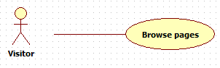

A visitor access the website homepage and by clicking the links in the navigation bar can navigate to the following pages:

* + About us
  + Contact us
  + Products (divided by category)
  + Product details

Prerequisites: none

Priority: High

* Browse catalogue

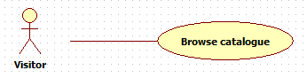

A visitor select a category from the drop down menu in the navigation bar.

The system populate the products page with product of the selected category

Prerequisites: The database is up and running.

Priority: High

* Search product

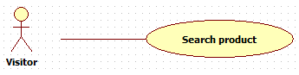

A visitor enters a value in the search box in the navigation bar.

The system retrieve from the database the record of the selected product and populate the product details page with the data.

If the record is not found an error mmessage is displayed to the user.

Prerequisites: The database is up and running.

Priority: Low

* View product details

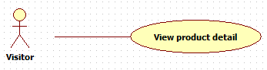

A visitor can select a specific product on the products page to view its detials.

The system retrieve from the database the record of the selected product and populate the product details page with the data.

Prerequisites: the customer is on a page that displays the products (Home page, Products page). The database is up and running.

Priority: High

* Register

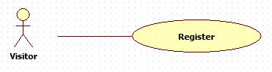

A visitor can register an account on the website.

A visitor enter email and password in the registration form.

The system check if the email entered is already in the system:

* + Email not in the system 🡪 The system add the new customer to the database
  + Email already in the system 🡪 The system dispalys an error message to the user.

Prerequisites: the email used for the registration has not already be used for registration and the database is up and running.

Priority: High

* Send message

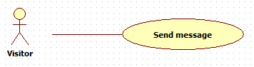

A visitor can send a message directly to the company.

The system sends themessage to the company’s email.

Prerequisites: The database is up and running.

Priority: Medium

# Requirement 2

Registered Customer

* Login

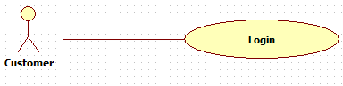

A customer can login into the system.

The customer enters email and password in the login form.

The system checks if the email exists in the database.

* + Email doesn’t exists 🡪 The system displays an error message to the user.
  + Email exists 🡪 The system checks is the password entered matches the email:
    - Password doesn’t match 🡪 The system displays an error message to the user.
    - Password matches 🡪 The system starts a session for the user.

Prerequisites: the customer is already registered and the database is up and running.

Priority: High

* Add to cart

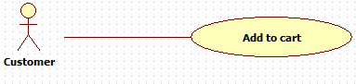

A customer can add a product to the shopping cart.

The system add the selected item and relative quantity in that customer’ session shopping cart.

Prerequisites: the customer is logged in, the product is available and the database is up and running.

Priority: High

* Checkout

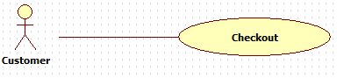

A customer can checkout to purchase the items in the shopping cart.

The customer fill the shipping etails form.

The customer fills the payment form.

The system call the selected payment method API.

* + Payment successful 🡪 The system creates the records in the database annd notiiesy the customer
  + Payment unsaccessful 🡪 The system notifies the cusotmer

Prerequisite: the customer is logged in, there are products in the shopping cart and the database is up and running.

Priority: High

# Requirement 3

Admin

* Login

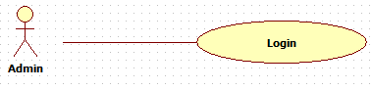

An admin can login to the system with admin credentials

The system checks if the email exists.

* + Email doesn’t exist 🡪 The system displays an error message to the admin.
  + Email exists 🡪 The system checks is the password entered matches the email:
    - Password doesn’t match 🡪 The system displays an error message to the admin.
    - Password matches 🡪 The system starts a session for the admin and opens the admin dashboard.

Prerequisites: the admin credentials are already in the database and the database is up and running.

Priority: High

* Create a new product

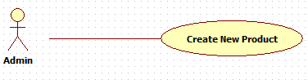

An admin can add a product to the inventory.

The admin enters the product details in the form.

The system create a new product and add it to the database.

Prerequisites: The admin is logged in, the product is not already in the databse and the database is up and running.

Priority: High

* View Product Details

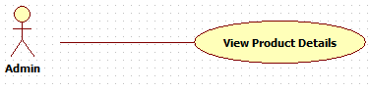

An admin can view a product’s details

Prerequisites: the admin is logged in and the database is up and running.

Priority: Medium

Update Product

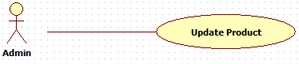

An admin can update the details of a product.

The admin enters the new product’s details in the form.

The system update the data in the databse and confirm tha changes to the admin.

Prerequisites: the admin is logged in and the database is up and running.

Priority: High

* Delete Products

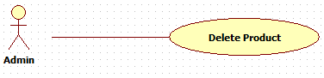

An admin can delete a product in the inventory

Prerequisites: the admin is logged in, the product is in the database and the database is up and running.

Priority: medium

* Create new customer

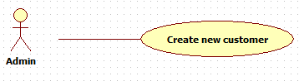

An admin can add a customer to the system.

The admin enters the customer’s details in the form.

The system create a new cusotmer and add it to the database.

Prerequisites: The admin is logged in, the customer is not already in the database and the database is up and running.

Priority: High

* View Customer Details

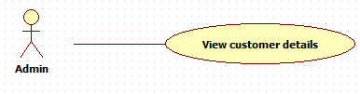

An admin can view a customer’s details

Prerequisites: the admin is logged in and the database is up and running.

Priority: High

Update Customer

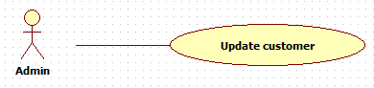

An admin can update the details of a customer.

The admin enters the new customer’s details in the form.

The system update the data in the databse and confirm tha changes to the admin.

Prerequisites: the admin is logged in and the database is up and running.

Priority: High

* Delete Customer

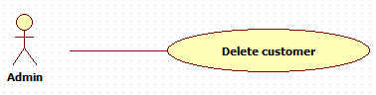

An admin can delete a customer account

Prerequisites: the admin is logged in, the customer is in the database and the database is up and running.

Priority: Medium

# Requirements of External Interface

# User Interfaces

The system will use Bootstrap 5.0 as a CSS framework to ensure responsitivity and a coherent design throughout all the pages.

Every screen will have a navigation bar at the top, to give access to the user to any page on the main level of navigation from anywhere in the website.

To keep the design consistent between different devices, the main content of each page will be displayed from top to bottom, without resorting to the use of *aside* tags or other elements on the side of the screen. This choice will replicate on desktop and laptop devices, the experience on a mobile platform, with the user scrolling down through the content of the pages.

The approach adopted is to keep the pages simple and minimal, with only the few and most important elements on screen at any time.

This choice is also reflected by the color palette, with no backgrounds behind the main content and light pale colors to highlight the boundaries between each section (e.g. navbar).

The following image serves as an example of the predicament applied to the design of the GUI for the Bazaar Ceramics Project.

It should be considered as an example only and the final design may vary.



# Hardware Interfaces

The system relies on a Server-Client archtecture. The client, from any device connected to the iternet through a web browser, creates a request and send it to the server, to which the server replies with a response that resolves that request.

With the data contained in the server response, the client renders the data to the screen for the user, applying the responsive attributes as provided by the server, for a customised visualisation of the data.

The server is a Microsoft Windows 2019 running Microsoft IIS 10.0 HTTP web server, MySQL 8.0 as a database engine and PHP as a server side programming language.

The system is stored in a datacenter that provides storage, networking and 24/7 security with a SLA of less than 99.99% but equal or greater than 99.0% (Amazon EC2).

# Software Interfaces

The system is built using PHP 7.4 as a server side language and runs on a Windows 2019 server with IIS as a HTTP server and MySQL 8.0 as database engine.

For the client side the system uses HTML 5.0 and Bootstrap 5 as a CSS framwork. Jquery is used as a Javascript library.

The system integrate consumes Google Mpas API for location purposes and Paypal and Stripe APIs to process online payment.

# Communication Interfaces

Some of the functionalities requires the system to be able to communicate with the user. Sign up confirmation, password recovery and password change, which all need to send email to the user, will be handled by PHPMailer.

The communication between client and server is be handled by the HTTP/2 protocol.

Database daily backup is handled by the IIS scheduler.

Code management is handled by GIT, suing the GIT-FTP extension.

# Non-functional Requirements

# Performance

The system is expected to completely load in less than 5 seconds. To achieve this standard all the external JS and CSS ill be stored using a Content Delivery Network (CDN) with a fallback on a local file, to be rendered only once jQuery is ready.

All of the JS and CSS files should be compressed and minified.

Caching is also used to improve loading time for returning visitors.

The system is expected to be able to handle at least 10.000 visits per month by using a PHP Data Object (PDO) for Object Relational Mapping (ORM), which creates a single connection to the database in order to avoid issues.

# Security

The system is expected to handle sensitive data, including financial information, that could become the target of malicious attackers.

To ensure the system’s protection, several measures have been put in place at every level of the application.

Server

* SSL
* Firewall
* Fail2Ban
* SSH Blocking

Programming

* HTML5 Form validation
* JavaScript validation
* Server side validation

Database

* PDO to prevent SQL injectionss
* Appropriate assignment and use of data types

Privacy policies

* The system complies with the regulations and guidelines provided by the Privacy Act 1988
* The system complies with the standards set by the Australian Privacy Principles.

# Quality

* Accessibility: The system is compatible with disabled people assistive technologys
* Accountability: The system keeps accurate record of property, documents and funds
* Adaptability: The system adapts its behaviour to individual users based on information acquired about its user(s) and its environment.
* Administrability: A backend for business administration is provided
* Availability: As per Service Level Agreement
* Compatibility: The system is compatible with different paltforms and with different browsers
* Learnability: The system is designed to allow users to easily and quickly complete any task
* Portability: The system can be accessed by any device that has access to the internet and a web browser